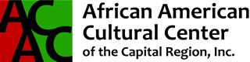

12th Annual

Albany’s Juneteenth Celebration
Sunday, June 12, 2016

Washington Park, Albany, New York
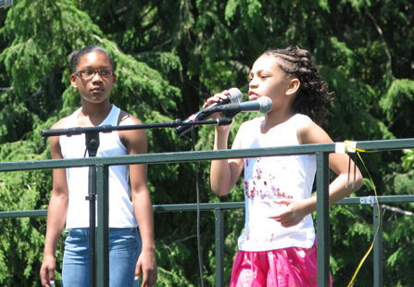
The African American Cultural Center, Mayor Kathy Sheehan and the City of Albany are proud to present the 12th Annual Juneteenth Celebration. Juneteenth is considered the date when the last slaves in America were freed. It symbolizes the end of slavery. Juneteenth has come to symbolize for many African-Americans what the Fourth of July symbolizes for all Americans—Freedom. It serves as a historical milestone reminding Americans of the triumph of the human spirit over the cruelty of slavery.

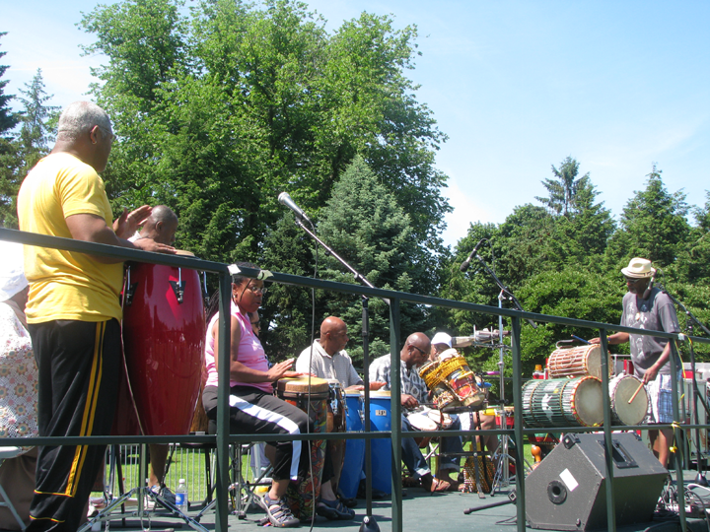Albany’s Juneteenth celebration is in beautiful Washington Park and features exciting musical entertainment on the main stage, a fun KidZone, information tables from local not for profit organizations and great food vendors. Attendees will enjoy a fun filled, educational day celebrating this historic occasion.

Juneteenth is a great opportunity to partner with AACCCR & the City of Albany in honoring this celebration of freedom! Please consider a donation today!

Juneteenth is the oldest known celebration commemorating the ending of slavery in the United States. Dating back to 1865, it was on June 19th that the Union soldiers, led by Major General Gordon Granger, landed at Galveston, Texas with news that the war had ended and that the enslaved were now free. Note that this was two and a half years after President Lincoln’s Emancipation Proclamation - which had become official January 1, 1863. There are a number of versions why it took so long for this to reach Texas, but when it did it was first received as shock then jubilation.

Today, many cities and communities across America celebrate Juneteenth as the official end of slavery. Celebrations typically include entertainment, community awareness activities and food.

Celebrating 12 Years!

12th Annual Albany’s Juneteenth Celebration

ALBANY’S JUNETEENTH 2016
SPONSORSHIP PACKAGES

PRESENTER LEVEL SPONSORSHIP: $5,000

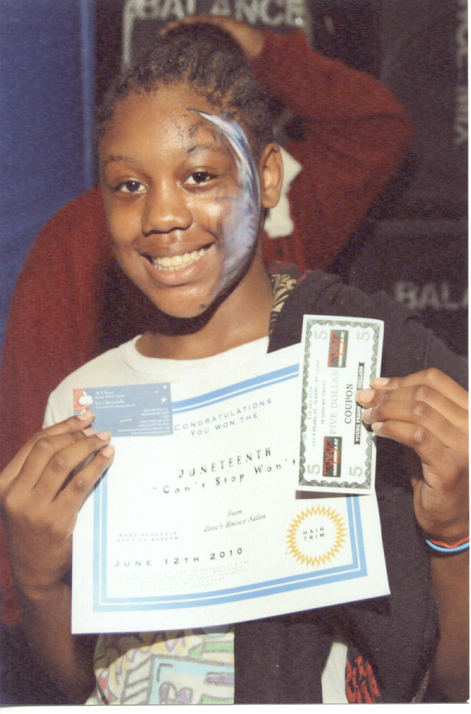
2016 Sponsor Benefits

- Premier size logo on event print collateral (flyers, program)
- Logo on print advertising
- Mention in all radio ads!
- Opportunity for your representative to speak on stage
- 10 X 10 space at event, includes table & 2 chairs
- Listing on all press releases!
- Recognition on sponsor section of our web page, www.albanyevents.org / www.aacccr.org

$1,000 SPONSORSHIP:

2016 Sponsor Benefits
- Secondary size logo on event print collateral (flyers, program)
- Listing on print advertising buys
- 10 X 10 space at event
- Listing on all press releases
- Recognition on sponsor section of our web page, www.albanyevents.org / www.aacccr.org

$500 SPONSORSHIP:

2016 Sponsor Benefits
- Listing on event print collateral (flyers, program)
- 10 X 10 space at event
- Listing on all press releases
- Recognition on sponsor section of our web page, www.albanyevents.org / www.aacccr.org

If you are interested in being a part of this unique sponsorship opportunity, please mail this entire packet with your level of choice & contribution or feel free to contact us for more information!

Linda Jackson-Chalmers Angela O’Neal
Program Committee Chair Executive Director
AACCCR.ORG aacuturalcentercapregion@gmail.com
Ljackson11@nycap.rr.com (518)621-7195

Yes! I am interested in becoming a partner for Albany’s Juneteenth 2016 at the _________ level!

Please accept my sponsorship amount of $___________ with the check enclosed.

Name of organization as you’d like it to appear: __________________________________________

Contact Person: ____________________________________________________________

Contact Phone: ____________________________________________________________

Contact Email: ____________________________________________________________

Contact Address: __________________________________________________________

_____________________________________________________________

